[1.5 0.5 1]

1 run...

Downloading: 100%

411/411 [00:00<00:00, 14.9kB/s]

Downloading: 100%

263M/263M [00:22<00:00, 12.7MB/s]

training 1 epoch...

730.198076248169 seconds used......

1 training finished! average train loss: 0.42519816079469197

evaluating...

Confusion matrix, without normalization

[[ 553 142 327]

[ 781 4260 366]

[ 175 209 10381]]

Normalized confusion matrix

[[0.54109589 0.13894325 0.31996086]

[0.14444239 0.78786758 0.06769003]

[0.01625639 0.01941477 0.96432884]]

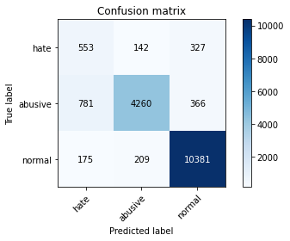

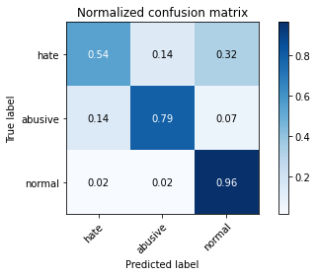

precision recall f1-score support

hate 0.37 0.54 0.44 1022

abusive 0.92 0.79 0.85 5407

normal 0.94 0.96 0.95 10765

accuracy 0.88 17194

macro avg 0.74 0.76 0.75 17194

weighted avg 0.90 0.88 0.89 17194

average eval_loss: 0.3089448667737807, accuracy: 0.883680353611725

training 2 epoch...

729.7974383831024 seconds used......

2 training finished! average train loss: 0.3215861211631917

evaluating...

Confusion matrix, without normalization

[[ 539 224 259]

[ 461 4680 266]

[ 338 288 10139]]

Normalized confusion matrix

[[0.52739726 0.21917808 0.25342466]

[0.08525985 0.86554466 0.04919549]

[0.03139805 0.02675337 0.94184858]]

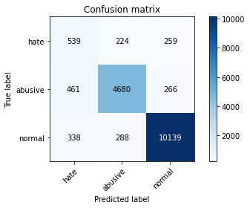

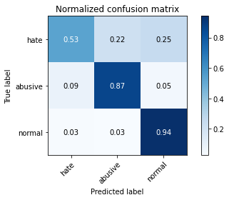

precision recall f1-score support

hate 0.40 0.53 0.46 1022

abusive 0.90 0.87 0.88 5407

normal 0.95 0.94 0.95 10765

accuracy 0.89 17194

macro avg 0.75 0.78 0.76 17194

weighted avg 0.90 0.89 0.90 17194

average eval_loss: 0.3167836316882871, accuracy: 0.8932185646155636

training 3 epoch...

729.9972674846649 seconds used......

3 training finished! average train loss: 0.2281928689053823

evaluating...

Confusion matrix, without normalization

[[ 516 214 292]

[ 547 4545 315]

[ 309 263 10193]]

Normalized confusion matrix

[[0.50489237 0.20939335 0.28571429]

[0.10116516 0.84057703 0.05825781]

[0.02870413 0.02443103 0.94686484]]

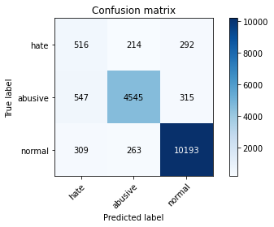

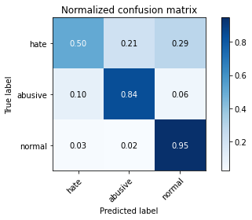

precision recall f1-score support

hate 0.38 0.50 0.43 1022

abusive 0.91 0.84 0.87 5407

normal 0.94 0.95 0.95 10765

accuracy 0.89 17194

macro avg 0.74 0.76 0.75 17194

weighted avg 0.90 0.89 0.89 17194

average eval_loss: 0.3494164941139346, accuracy: 0.8871699430033733

training 4 epoch...

730.3694822788239 seconds used......

4 training finished! average train loss: 0.1466886547433016

evaluating...

Confusion matrix, without normalization

[[ 536 211 275]

[ 652 4440 315]

[ 407 261 10097]]

Normalized confusion matrix

[[0.52446184 0.20645793 0.26908023]

[0.12058443 0.82115776 0.05825781]

[0.03780771 0.02424524 0.93794705]]

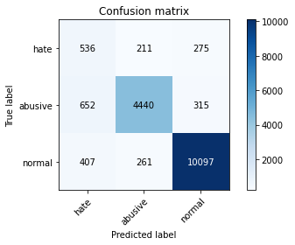

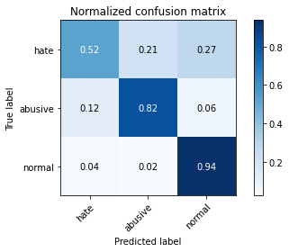

precision recall f1-score support

hate 0.34 0.52 0.41 1022

abusive 0.90 0.82 0.86 5407

normal 0.94 0.94 0.94 10765

accuracy 0.88 17194

macro avg 0.73 0.76 0.74 17194

weighted avg 0.90 0.88 0.88 17194

average eval_loss: 0.4717343444616512, accuracy: 0.8766430150052343

training 5 epoch...

730.0720512866974 seconds used......

5 training finished! average train loss: 0.1080438601571037

evaluating...

Confusion matrix, without normalization

[[ 503 282 237]

[ 506 4685 216]

[ 566 391 9808]]

Normalized confusion matrix

[[0.49217221 0.27592955 0.23189824]

[0.09358239 0.86646939 0.03994822]

[0.0525778 0.03632141 0.91110079]]

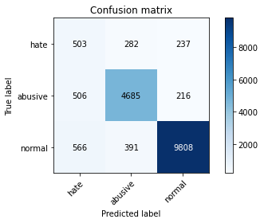

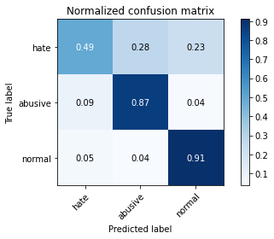

precision recall f1-score support

hate 0.32 0.49 0.39 1022

abusive 0.87 0.87 0.87 5407

normal 0.96 0.91 0.93 10765

accuracy 0.87 17194

macro avg 0.72 0.76 0.73 17194

weighted avg 0.89 0.87 0.88 17194

average eval_loss: 0.5227855631112402, accuracy: 0.8721647086192857

2 run...

training 1 epoch...

730.7692251205444 seconds used......

1 training finished! average train loss: 0.42813293474980374

evaluating...

Confusion matrix, without normalization

[[ 516 232 274]

[ 437 4731 239]

[ 262 305 10198]]

Normalized confusion matrix

[[0.50489237 0.22700587 0.26810176]

[0.08082116 0.87497688 0.04420196]

[0.02433813 0.02833256 0.94732931]]

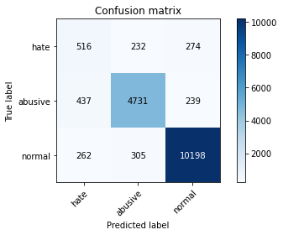

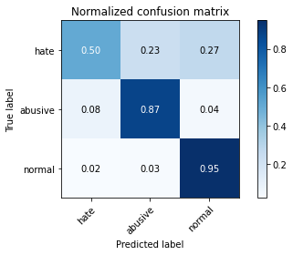

precision recall f1-score support

hate 0.42 0.50 0.46 1022

abusive 0.90 0.87 0.89 5407

normal 0.95 0.95 0.95 10765

accuracy 0.90 17194

macro avg 0.76 0.78 0.77 17194

weighted avg 0.90 0.90 0.90 17194

average eval_loss: 0.32066310139069726, accuracy: 0.8982784692334536

training 2 epoch...

730.6850433349609 seconds used......

2 training finished! average train loss: 0.32351367062919084

evaluating...

Confusion matrix, without normalization

[[ 603 184 235]

[ 668 4490 249]

[ 488 257 10020]]

Normalized confusion matrix

[[0.59001957 0.18003914 0.22994129]

[0.12354355 0.83040503 0.04605141]

[0.04533209 0.02387366 0.93079424]]

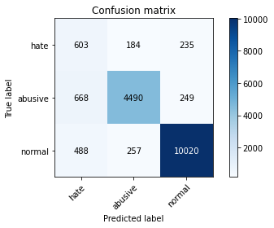

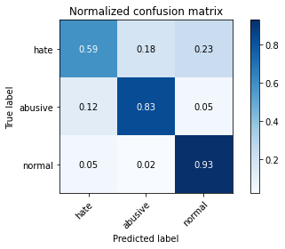

precision recall f1-score support

hate 0.34 0.59 0.43 1022

abusive 0.91 0.83 0.87 5407

normal 0.95 0.93 0.94 10765

accuracy 0.88 17194

macro avg 0.74 0.78 0.75 17194

weighted avg 0.90 0.88 0.89 17194

average eval_loss: 0.33384179507577144, accuracy: 0.8789694079329999

training 3 epoch...

730.8531503677368 seconds used......

3 training finished! average train loss: 0.23208209099261706

evaluating...

Confusion matrix, without normalization

[[ 518 246 258]

[ 453 4712 242]

[ 372 327 10066]]

Normalized confusion matrix

[[0.50684932 0.2407045 0.25244618]

[0.08378028 0.87146292 0.0447568 ]

[0.03455643 0.03037622 0.93506735]]

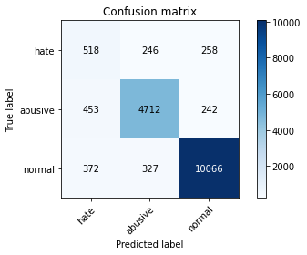

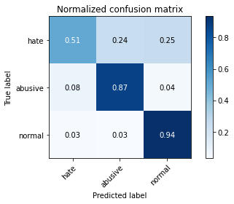

precision recall f1-score support

hate 0.39 0.51 0.44 1022

abusive 0.89 0.87 0.88 5407

normal 0.95 0.94 0.94 10765

accuracy 0.89 17194

macro avg 0.74 0.77 0.75 17194

weighted avg 0.90 0.89 0.89 17194

average eval_loss: 0.3728110408150526, accuracy: 0.889612655577527

training 4 epoch...

730.9909365177155 seconds used......

4 training finished! average train loss: 0.1528650689139536

evaluating...

Confusion matrix, without normalization

[[ 581 187 254]

[ 756 4422 229]

[ 515 317 9933]]

Normalized confusion matrix

[[0.56849315 0.18297456 0.24853229]

[0.13981875 0.81782874 0.04235251]

[0.04784022 0.02944728 0.92271249]]

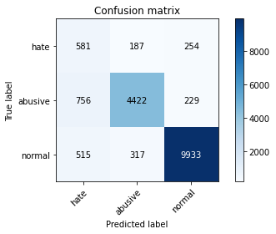

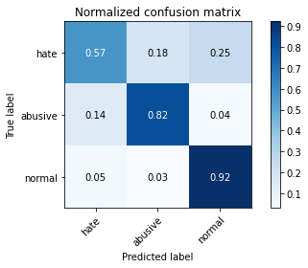

precision recall f1-score support

hate 0.31 0.57 0.40 1022

abusive 0.90 0.82 0.86 5407

normal 0.95 0.92 0.94 10765

accuracy 0.87 17194

macro avg 0.72 0.77 0.73 17194

weighted avg 0.90 0.87 0.88 17194

average eval_loss: 0.4649520674184355, accuracy: 0.8686751192276375

training 5 epoch...

731.5249381065369 seconds used......

5 training finished! average train loss: 0.11089414192093577

evaluating...

Confusion matrix, without normalization

[[ 570 182 270]

[ 793 4320 294]

[ 388 298 10079]]

Normalized confusion matrix

[[0.55772994 0.17808219 0.26418787]

[0.14666173 0.79896431 0.05437396]

[0.03604273 0.0276823 0.93627497]]

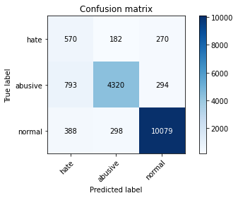

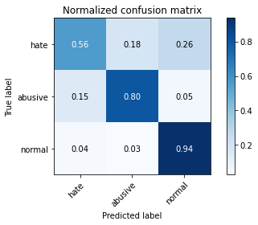

precision recall f1-score support

hate 0.33 0.56 0.41 1022

abusive 0.90 0.80 0.85 5407

normal 0.95 0.94 0.94 10765

accuracy 0.87 17194

macro avg 0.72 0.76 0.73 17194

weighted avg 0.90 0.87 0.88 17194

average eval_loss: 0.5616305072739082, accuracy: 0.8705943933930441